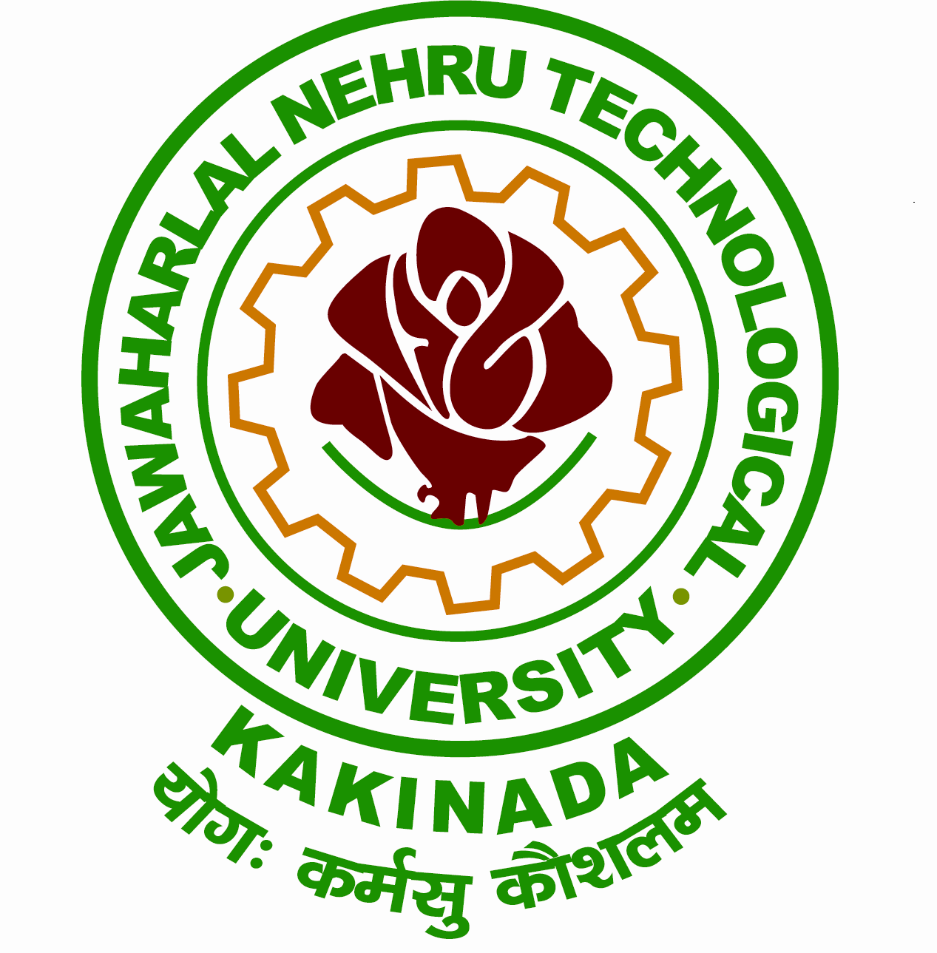
Website: www.jntuk.edu.in Phone: Off: 0884 -2300900
Email:registrar@jntuk.edu.in Fax: 0884 -2300901

JAWAHARLAL NEHRU TECHNOLOGICAL UNIVERSITY KAKINADA
KAKINADA-533003, Andhra Pradesh (India)
(Established by Andhra Pradesh Act No. 30 of 2008)
---------------------------------------------------------------------------------------------------------------------
Lr.No.JNTUK/Mega Blood Donation Camp/2025 Date: .24.03.2025

To
The Principals,
Constituent & Affiliated Colleges of
Kakinada, East Godavari & Dr. B. R. Ambedkar Konassema
Districts under JNTUK, Kakinada.

CIRCULAR

Sub:- JNTUK Kakinada – NSS Cell – Conduct of Mega Blood Donation Camp will be held on
28th March, 2025 – Reg.

***
I am by the direction of Hon’ble Vice-Chancellor wish to inform you that, the JNTUK Kakinada NSS Cell is organizing a Mega Blood Donation Camp in association with the Indian Red Cross Society on Friday, 28th March 2025. The event will take place at the Alumni Auditorium, JNTUK Kakinada, starting from 9:30 AM onwards.

In this connection, College principals of Kakinada, East Godavari and Dr.B.R.Ambedkar Konaseema Districts are requested to depute minimum of 100 students from each college and thereby encourage as many Blood Donors as possible.

Prof. CSRK Prasad garu, Hon’ble Vice-Chancellor will grace the occasion and inaugurate the Mega Blood Donation Camp.

Note:
1. To ensure maximum participation in the Mega Blood Donation Camp, College Principals
are kindly advised to avoid organizing separate blood donation camps prior to this event.
2. Please inform to the NSS Programme Officers to encourage above 18 years old students.

NSS Programme Coordinator REGISTRAR

To
Copy to the Secretary to the Hon’ble Vice-Chancellor, JNTUK Kakinada
Copy to the Rector, JNTUK Kakinada
Copy to the OSD, JNTUK Kakinada
Copy to Coordinator, NSS, JNTUK Kakinada.

Website: www.jntuk.edu.in Phone: Off: 0884 -2300900
Email:registrar@jntuk.edu.in Fax: 0884 -2300901

JAWAHARLAL NEHRU TECHNOLOGICAL UNIVERSITY KAKINADA
KAKINADA-533003, Andhra Pradesh (India)
(Established by Andhra Pradesh Act No. 30 of 2008)
---------------------------------------------------------------------------------------------------------------------
Lr.No.JNTUK/Mega Blood Donation Camp/2025 Date: .24.03.2025

To
The Principals,
Constituent & Affiliated Colleges of
Kakinada, East Godavari & Dr. B. R. Ambedkar Konassema
Districts under JNTUK, Kakinada.

CIRCULAR

Sub:- JNTUK Kakinada – NSS Cell – Conduct of Mega Blood Donation Camp will be held on
28th March, 2025 – Reg.

***
I am by the direction of Hon’ble Vice-Chancellor wish to inform you that, the JNTUK Kakinada NSS Cell is organizing a Mega Blood Donation Camp in association with the Indian Red Cross Society on Friday, 28th March 2025. The event will take place at the Alumni Auditorium, JNTUK Kakinada, starting from 9:30 AM onwards.

In this connection, College principals of Kakinada, East Godavari and Dr.B.R.Ambedkar Konaseema Districts are requested to depute minimum of 100 students from each college and thereby encourage as many Blood Donors as possible.

Prof. CSRK Prasad garu, Hon’ble Vice-Chancellor will grace the occasion and inaugurate the Mega Blood Donation Camp.

Note:
1. To ensure maximum participation in the Mega Blood Donation Camp, College Principals
are kindly advised to avoid organizing separate blood donation camps prior to this event.
2. Please inform to the NSS Programme Officers to encourage interest above 18 years old
students.

REGISTRAR

To
Copy to the Secretary to the Hon’ble Vice-Chancellor, JNTUK Kakinada
Copy to the Rector, JNTUK Kakinada
Copy to the OSD, JNTUK Kakinada
Copy to Coordinator, NSS, JNTUK Kakinada.

