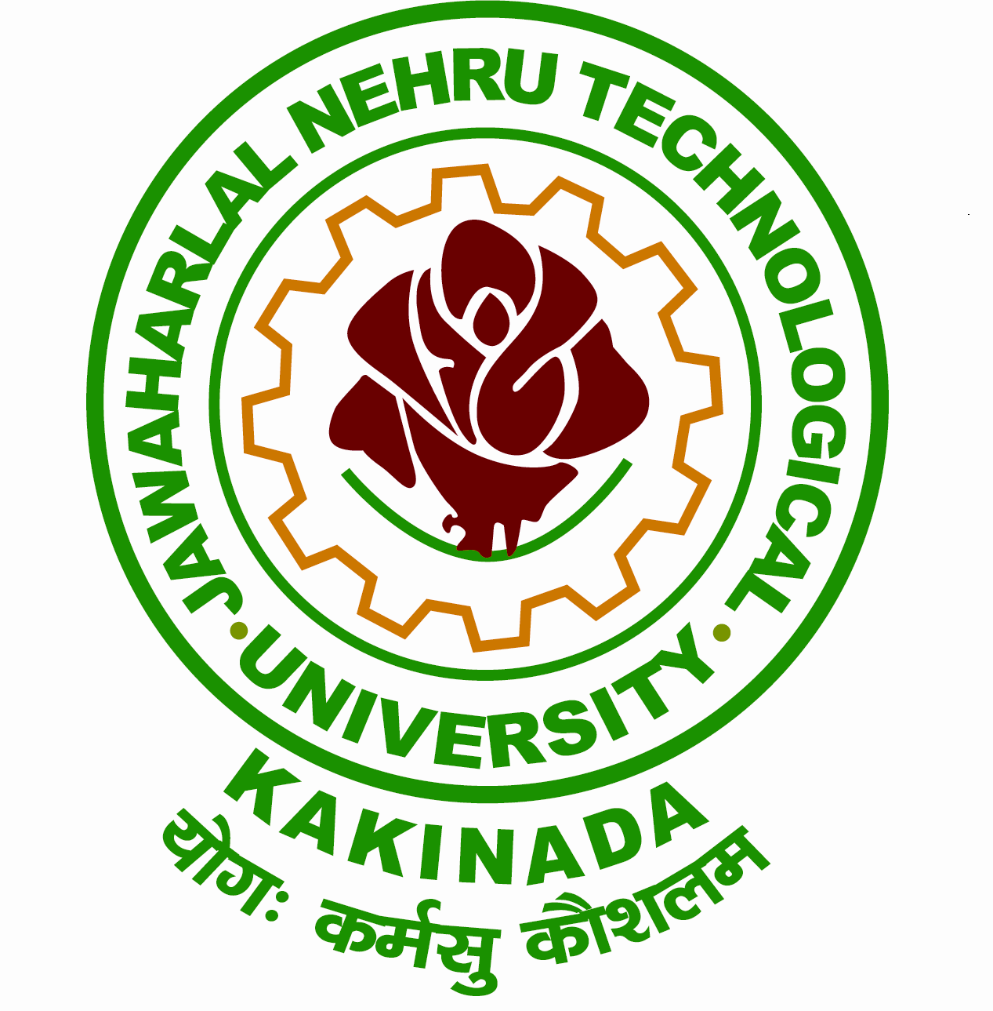
Website: www.jntuk.edu.in Phone: Off: 0884 -2300900
Email:registrar@jntuk.edu.in Fax: 0884 -2300901
JAWAHARLAL NEHRU TECHNOLOGICAL UNIVERSITY KAKINADA
KAKINADA-533003, Andhra Pradesh (India)
(Established by Andhra Pradesh Act No. 30 of 2008)
----------------------------------------------------------------------------------------------------------
Proc. No. JNTUK/NSS Cell/NSS Volunteers Deputation to Pre RD Camp/ 2024-25 Date: 20.09.2024

Prof. V. Ravindranath
M.Sc. (IITKGP), Ph.D. (IITD),
REGISTRAR

To
The Principals and NSS Programme Officers,
Constituent and Affiliated Colleges under J.N.T University (K)
Kakinada.

Sub:- West Zone NSS Pre - Republic Day Parade Camp-2024 – Selection and deputation
of NSS Volunteers – Guidelines for University Level Selections – Reg.
Ref:- F.No.HRC/P-8/2024-25/376, Ministry of Youth Affairs & Sports Government of
India and Regional Directorate of NSS.

***
Sir / Madam,
With reference to the subject cited above, it is to inform you that the West Zone NSS Pre-Republic Day Parade Camp-2024, scheduled in Maharashtra (venue and dates to be announced later). This camp will bring together NSS volunteers from Andhra Pradesh, Telangana, Maharashtra, Goa, Gujarat, Daman & Diu, and Dadra Nagar Haveli. The 10-day camp will include rigorous training and zonal-level selection. Selected volunteers will participate in the NSS Republic Day Parade Camp-2025 in New Delhi from January 1-31, 2025.
In this connection, the NSS Cell, JNTUK and the Regional Directorate, NSS, Hyderabad will select outstanding volunteers on 26th September, 2024 (Thursday), at JNTUK Kakinada in Indoor Stadium. Please nominate one girl and one boy NSS volunteer from your college to attend this selections.
Thanking you,

REGISTRAR
JNTUK Kakinada

